CASE STUDY REPORT
Predictive Hardware Failure Analytics
Transforming Raw Data into Actionable Insights through Data Preprocessing, Analysis, and Visualization
A Data Science Case Study on Predictive Maintenance for Enterprise Hard Disk Drives, based on the Backblaze Hard Drive Data Set (Q1 2026)
Submitted by: Group Project Team
Vishwajeet Singh (Member 5 — Insights, Report & Presentation Coordination) and Team
MCA Program, JAIN (Deemed-to-be University), Bengaluru
Course: Data Science — Activity 1
Faculty: Dr. I Brem Navas
Date: August 2026 (Revised Edition — updated after re-execution of preprocessing, EDA and visualization code)

Abstract
Unplanned hard-disk-drive failure is one of the most common causes of data loss and service downtime in data centres. This case study applies a complete data-science pipeline — preprocessing, exploratory data analysis (EDA), and visualization — to a large-scale, real-world hard-drive telemetry dataset in order to understand the statistical and behavioural signature of drive failure. The working dataset, drawn from Backblaze's publicly published daily hard-drive “Drive Stats” telemetry, contains 30,943,146 daily SMART (Self-Monitoring, Analysis and Reporting Technology) records for 351,095 individual drives spanning 80 drive models over a 90-day observation window (1 January – 31 March 2026).
Following a revision of the project's code, this edition of the report reflects a change in how the three analytical stages are chained together. Data preprocessing (Member 2) still removes 345,662 exact duplicate records, imputes missing SMART readings by median/mode substitution, caps statistical outliers using the interquartile-range (IQR) method, and standardizes 15 continuous features, producing a clean analytical file of 30,597,484 records with zero missing values and zero duplicates. However, the exploratory analysis (Member 3) and visualization (Member 4) notebooks were both re-pointed to read directly from the original, uncleaned source file rather than from that cleaned output. As a result, every statistic and chart in Sections 5 and 6 of this report characterises the raw 30,943,146-row feed — duplicates, missing values, and all — rather than the cleaned dataset. This is not simply an error to be hidden: analysing the raw feed recovers real signal that the earlier (cleaned-and-imputed) analysis had inadvertently erased. Most notably, SMART 188 (Command Timeout, raw) now shows the strongest measured association with failure of any feature in the dataset (r = +0.118), a relationship that had collapsed to zero after median imputation in the previous edition of this study.
The revised analysis still confirms an extremely imbalanced target variable — only 1,054 of 30,943,146 daily records (0.0034%) are associated with a drive-failure event — and identifies capacity_bytes and smart_9_raw (power-on hours) as strongly correlated with one another (r ≈ ‑0.72). Eight visualizations (bar, line, histogram, scatter, box, pie, correlation heatmap, and a failure-conditioned box plot) further characterise the distribution of drive capacities, failure proportions, and inter-feature relationships on the raw feed. The study also surfaces two methodological limitations introduced by the code revision: several of Member 3's statistics (correlation matrix, failure correlations, anomaly counts, and failure-conditioned group means) were computed from only the first 500,000 rows of the file — a non-random, date-ordered slice covering under two of the ninety observation days — and a floating-point cancellation error produced a mathematically impossible negative variance for capacity_bytes. Both issues, along with the pipeline disconnect between the cleaned and analysed files, are documented as findings and carried into concrete recommendations for the next revision of the codebase and the next phase of model development.

1. Introduction
Modern organisations increasingly rely on large fleets of hard disk drives (HDDs) to store business-critical data. Because drives fail without warning, unplanned failures create risk of data loss, degrade service availability, and raise operational costs associated with emergency replacement and RAID rebuilds. Predictive maintenance — using a drive's own internal health telemetry to anticipate failure before it happens — is widely regarded as a more efficient alternative to purely reactive or purely time-based (calendar) maintenance strategies.
Every modern hard drive continuously records SMART (Self-Monitoring, Analysis and Reporting Technology) attributes: internal counters and sensor readings such as reallocated sector count, power-on hours, seek error rate, and temperature. Backblaze, a cloud storage and backup provider, has published daily SMART snapshots for its production drive fleet since 2013, creating one of the largest publicly available datasets for HDD-failure research. This case study uses a 2026 first-quarter extract of that dataset as the foundation for a complete, five-stage group data-science exercise: data collection, preprocessing, exploratory data analysis, visualization, and insight synthesis.
This report documents the full pipeline followed by the project team and consolidates the results produced at each stage into a single, decision-oriented narrative. It has been revised to reflect changes the team made to the preprocessing, EDA, and visualization notebooks since the previous edition — in particular, a change to which file the EDA and visualization stages read from — and calls out, explicitly, where that change altered the numbers and conclusions reported previously.

2. Problem Statement
Data-centre operators need to know, from daily SMART telemetry, which drives are at elevated risk of failing so that pre-emptive replacement or data migration can be scheduled. The problem this case study addresses is therefore twofold:
- Data-quality problem: the raw daily telemetry feed contains missing SMART values (ranging from under 1% to over 86% missing depending on the attribute), duplicate daily records, and extreme outliers, all of which must be resolved before the data can support reliable analysis or modelling.
- Analytical problem: drive failure is a rare event (a severe class-imbalance problem), so the study must characterise which SMART attributes, drive models, and capacity classes are statistically associated with failure, using descriptive statistics, correlation analysis, and visualization, as a foundation for future predictive modelling.
The scope of this case study is limited to preprocessing, exploratory analysis, and visualization of the telemetry feed; construction and evaluation of a trained failure-prediction classifier is identified as future work in the Recommendations section. A third, process-level problem emerged from this revision and is treated as an in-scope finding rather than out-of-scope noise: keeping the preprocessing, EDA, and visualization notebooks reading from a single, agreed source file as the pipeline evolves.

3. Dataset Description

3.1 Source
The dataset used in this study is a daily hard-drive SMART telemetry extract in the style of Backblaze's publicly released “Hard Drive Data and Stats” (Drive Stats) dataset, which Backblaze has published quarterly since 2013 for research and industry use. The working file supplied to the team, backblaze_analytical_dataset.csv, follows the standard Backblaze Drive Stats schema (date, serial_number, model, capacity_bytes, failure, and paired *_normalized / *_raw SMART attribute columns).
Reference: Backblaze, Inc. — “Hard Drive Data and Stats” (Drive Stats), publicly available dataset, https://www.backblaze.com/cloud-storage/resources/hard-drive-test-data (accessed 2026).

3.2 Structure and Characteristics
Characteristic | Value
Original records (rows) | 30,943,146
Original attributes (columns) | 19
Observation window | 90 days (1 Jan 2026 – 31 Mar 2026)
Unique drives (serial numbers) | 351,095
Distinct drive models | 80
Target / label variable | failure (0 = healthy, 1 = failed on that day)
Feature types | 3 categorical (date, serial_number, model), 16 numeric (capacity + 7 paired SMART attributes)
Records after Member-2 cleaning | 30,597,484
Records used in Member 3 EDA / Member 4 visualization (this edition) | 30,943,146 — the raw, uncleaned file (see Section 7, Finding 6)
The 16 numeric attributes comprise capacity_bytes, the binary failure flag, and seven SMART parameters, each reported in both a normalized (0–253 vendor-scaled) and a raw form:
SMART ID | Attribute | Typical meaning
SMART 5 | Reallocated Sectors Count | Sectors remapped after being marked defective — an early physical-wear indicator
SMART 9 | Power-On Hours | Cumulative hours the drive has been powered on (a proxy for drive age/usage)
SMART 90 | Unknown / Vendor-specific | Vendor-specific attribute (present mainly on a subset of models)
SMART 187 | Reported Uncorrectable Errors | Errors that could not be recovered using hardware ECC
SMART 188 | Command Timeout | Count of aborted operations due to drive timeout
SMART 197 | Current Pending Sector Count | Unstable sectors awaiting remapping
SMART 198 | Uncorrectable Sector Count | Sectors that failed the hardware ECC and read/verification

3.3 Fitness for the Case Study
With over 30 million records, 351,095 unique physical devices, and both a well-defined binary outcome (failure) and 14 continuous predictor variables, the dataset comfortably exceeds the assignment's minimum requirement of 500 records with multiple attributes, and its scale (multi-gigabyte, tens of millions of rows) additionally required the team to apply memory-aware engineering practices (chunked reading, dtype conversion, sparse encoding, float32 downcasting) throughout preprocessing, EDA, and visualization.

4. Data Preprocessing Methodology
Preprocessing was carried out in Python (pandas, NumPy, scikit-learn) on the full 30.9-million-row raw file, using memory-safe techniques (float32/int8 downcasting, sparse dummy encoding, explicit garbage collection) so that the entire pipeline could run on a standard workstation. This stage of the pipeline (Member 2) was re-run for this edition and produced results identical to the previous edition — the 21-step methodology below is unchanged.

4.1 Missing-Value Analysis and Treatment
Missing-value rates varied sharply by SMART attribute, driven by the fact that not every drive model reports every SMART parameter:
Column | Missing (%) | Treatment
smart_90_normalized / raw | 86.35% | Median imputation
smart_188_normalized / raw | 66.91% | Median imputation
smart_187_normalized / raw | 66.82% | Median imputation
smart_197_normalized / raw | 2.51% | Median imputation
smart_198_normalized / raw | 0.77% | Median imputation
smart_5_normalized / raw | 0.67% | Median imputation
smart_9_normalized / raw | 0.13% | Median imputation
date, serial_number, model, capacity_bytes, failure | 0.00% | No treatment required
All numeric columns were imputed using their column median (robust to skew); the three categorical columns (date, serial_number, model) had no missing values and required no mode imputation in practice. After treatment, total missing values across the Member-2 cleaned dataset were reduced from 122,124,538 cell-level nulls to zero.

4.2 Duplicate Records
An exact row-level duplicate check identified 345,662 fully duplicated records (1.12% of the raw file), which were removed using drop_duplicates(). A second duplicate check after cleaning confirmed zero duplicates remained in the Member-2 output.

4.3 Outlier Detection and Treatment
Outliers in each numeric feature (excluding the binary target) were flagged using the standard 1.5×IQR rule and then capped (winsorized) to the lower/upper bound rather than deleted, preserving sample size while limiting the influence of extreme values:
Feature | Outliers Detected (1.5×IQR)
smart_90_raw | 3,941,911
capacity_bytes | 1,868,933
smart_5_raw | 1,570,312
smart_188_raw | 662,232
smart_197_raw | 612,655
smart_187_raw | 457,208
smart_187_normalized | 456,490
smart_198_raw | 423,526
smart_5_normalized | 136,230
smart_197_normalized | 23,502
smart_198_normalized | 21,168
smart_9_raw | 4,462
smart_188_normalized | 796
smart_9_normalized / smart_90_normalized | 0
All flagged values were clipped to their respective [Q1 − 1.5×IQR, Q3 + 1.5×IQR] bounds using pandas' clip() function.

4.4 Categorical Encoding and High-Cardinality Handling
The team checked serial_number for high-cardinality identifier risk (351,095 unique values, 1.15% of rows) but retained it since its uniqueness ratio fell below the 50% removal threshold used and the field carries per-drive tracking value. date and model were left in their native form because both exceeded the 20-category one-hot-encoding threshold set for memory safety (90 and 80 unique values respectively); no categorical column required or received one-hot encoding in this pass.

4.5 Transformation and Standardization
- Log transformation: each numeric feature's skewness was evaluated and log1p() would have been applied to any feature with skew > 1 and a non-negative minimum; after outlier capping, none of the 15 candidate features met this threshold, so no log transform was ultimately required.
- Standardization: the 15 continuous SMART/capacity features (excluding the binary failure target and the non-encoded categorical columns) were standardized with scikit-learn's StandardScaler (zero mean, unit variance), applied column-by-column in float32 to control memory footprint.
- Data type optimisation: scaled features were stored as float32 rather than float64, roughly halving numeric memory usage; the final in-memory footprint was reduced from 9,190.94 MB (raw) to 7,337.45 MB (cleaned).

4.6 Preprocessing Summary
Metric | Value
Original rows | 30,943,146
Original columns | 19
Duplicates removed | 345,662
Final duplicate rows | 0
Remaining missing values | 0
High-cardinality ID columns removed | 0
Categorical columns encoded | 0
Categorical columns not encoded (retained as-is) | 3
Columns standardized | 15
Final rows | 30,597,484
Final columns | 19
The cleaned, standardized dataset (cleaned_disk_smart_data.csv) was exported by Member 2 as intended to be the single source of truth for downstream analysis. As documented in Section 7 (Finding 6), the EDA and visualization notebooks in this revision were not re-pointed to this file, and instead read the original raw source file directly — a discrepancy that is analysed rather than corrected in this report, since it produced findings of independent value.

5. Exploratory Data Analysis
In this revision of the code, the EDA notebook (Member 3) reads directly from the original 30,943,146-row raw source file, backblaze_analytical_dataset.csv, using a chunked, memory-efficient methodology (100,000-row chunks for full-population statistics such as counts, sums, and missing-value totals) rather than the Member-2 cleaned file used in the previous edition. Consequently, the statistics below describe the fleet's telemetry before deduplication, imputation, outlier capping, or standardization — duplicate rows, missing values, and extreme raw-unit values are all still present.

5.1 Descriptive Statistics (raw feed, N = 30,943,146)
Because these statistics are computed on unprocessed data, they are reported in each feature's native unit (bytes, hours, error counts, or the SMART 0–253 normalized scale) rather than as standardized (mean-0, variance-1) values as in the previous edition:
Feature | Mean | Median | Std. Dev. | Skewness | Interpretation
capacity_bytes (bytes) | 1.565 × 10^13 | 1.600 × 10^13 | n/a * | -0.27 | Approximately symmetric
failure (0/1) | 0.0000341 | 0 | 0.00584 | 408.25 | Extremely rare positive class
smart_9_normalized | 63.15 | 76.0 | 34.96 | -0.57 | Moderately negatively skewed
smart_9_raw (power-on hrs) | 31,146.5 | 28,002 | 18,926.6 | 0.39 | Approximately symmetric
smart_90_normalized | 100.00 | 100.0 | 0.00 | 0.00 | Constant where reported (13.65% coverage)
smart_187_normalized | 99.01 | 100.0 | 8.08 | -10.79 | Highly negatively skewed
smart_188_normalized | 100.00 | 100.0 | 0.36 | -335.03 | Extremely negatively skewed
smart_197_raw | 4.72 | 0.0 | 723.34 | 576.30 | Extremely positively skewed
smart_198_raw | 3.43 | 0.0 | 712.96 | 591.31 | Most extreme positive skew in the dataset
* Member 3's incremental variance formula (sum-of-squares minus mean-squared, divided by n − 1) produced a mathematically impossible negative variance for capacity_bytes (−2.4495 × 10^26), which propagates to an undefined (NaN) standard deviation. This is a floating-point cancellation artifact: capacity values are on the order of 10^13, so squaring and summing them across 30.9 million rows exceeds the safe precision range of a 64-bit float. It is not a property of the data and is discussed as Finding 8 in Section 7.

5.2 Class Balance of the Target Variable
failure | Record Count | Percentage
0 (healthy) | 30,942,092 | 99.9966%
1 (failed) | 1,054 | 0.0034%
This is an extreme class imbalance — roughly 1 failure event for every 29,357 healthy daily records — consistent with published Backblaze annualised failure rates of well under 2%. The count of 1,054 raw failure records is 24 higher than the 1,030 reported for the cleaned dataset in the previous edition, because 24 of the 345,662 removed duplicate rows happened to carry failure = 1. This is still the single most important characteristic to account for in any future predictive model built on this data.

5.3 Correlation Structure
A Pearson correlation matrix was computed by Member 3 from a fixed sample of the first 500,000 rows read from the file (roughly the first day and a half of the 90-day window, since the file appears date-ordered), not a random sample and not the full population. This is a methodology limitation carried into every result in this subsection and is discussed further as Finding 7 in Section 7. With that caveat, the strongest inter-feature relationships (ranked by absolute correlation) were:
Feature 1 | Feature 2 | Correlation (r) | Strength
smart_197_raw | smart_198_raw | +0.994 | Very strong positive
smart_188_normalized | smart_197_raw | -0.932 | Very strong negative
smart_188_normalized | smart_198_raw | -0.932 | Very strong negative
smart_5_normalized | smart_197_normalized | +0.877 | Strong positive
capacity_bytes | smart_9_raw (power-on hours) | -0.719 | Strong negative
smart_197_normalized | smart_198_normalized | +0.625 | Moderate positive
smart_9_normalized | smart_9_raw | -0.604 | Moderate negative
Unlike the previous edition — where six of the seven paired SMART attributes had collapsed to a constant value after median imputation and therefore produced undefined correlations — the raw feed retains genuine variability in SMART 187, 188, 197 and 198 wherever a drive model reports them, and these attributes now show some of the strongest correlations in the entire dataset. The failure-specific correlations were:
Feature | Correlation with failure | Strength
smart_188_raw | +0.1178 | Weak positive — strongest in the dataset
smart_187_normalized | -0.0367 | Weak negative
smart_187_raw | +0.0054 | Negligible
smart_9_raw (power-on hours) | +0.0019 | Negligible
capacity_bytes | -0.0012 | Negligible
smart_9_normalized | -0.0012 | Negligible
smart_90_normalized / smart_90_raw | undefined | Not present in the 500K-row sample used
This is the single most consequential change from the previous edition: smart_188_raw (Command Timeout) now shows a materially larger association with failure (r = +0.118) than either power-on hours or capacity — attributes that were previously considered the dataset's only usable predictors. Because this figure is drawn from a small, non-random opening slice of the file, it should be treated as a lead to validate against the full 30.9-million-row population, not as a confirmed effect size (see Finding 7).

5.4 Failure-Conditioned Comparison
Member 4's visualization notebook independently computed capacity_bytes by failure status across the full 30,943,146-row population (Section 6.8), giving:
Feature (raw units) | Mean — Healthy (failure=0) | Mean — Failed (failure=1)
capacity_bytes (bytes) | 1.565 × 10^13 | 1.476 × 10^13
Failed drives have, on average, smaller capacity than healthy drives in the full population — consistent with the direction reported in the previous edition. This full-population result is treated as authoritative in this report. It is worth noting, however, that Member 3's own group-mean calculation (step_50, based on only the first 50,000 rows of the file) produced the opposite direction for this same comparison (healthy mean 1.544 × 10^13 vs. failed mean 1.600 × 10^13) — a sign disagreement caused entirely by the small, non-random sample containing very few of the fleet's 1,054 failure events. This discrepancy is analysed as Finding 7 in Section 7 and is a direct illustration of why rare-event statistics must be computed on the full population or a genuinely random sample.

5.5 Anomaly Detection (Z-score > 3, first-500,000-row sample)
A z-score screen (|z| > 3) was applied to the same first-500,000-row sample used for the correlation analysis above:
Feature | Anomalies (|z| > 3) | Feature | Anomalies (|z| > 3)
capacity_bytes | 5,510 | smart_188_raw | 384
smart_90_raw | 1,603 | smart_198_normalized | 180
smart_187_normalized | 1,174 | smart_197_normalized | 179
smart_5_raw | 862 | smart_9_raw | 133
smart_5_normalized | 699 | smart_197_raw | 98
smart_198_raw | 42 | smart_187_raw | 27
smart_188_normalized | 7 | failure | 3
smart_9_normalized | 0 | smart_90_normalized | 0
Because the underlying sample is a narrow, date-ordered opening slice rather than the full file, these counts should be read as a diagnostic of that slice rather than of fleet-wide anomaly incidence; a full-population or randomly sampled re-run is recommended (Section 8.2).

5.6 Drive-Model Frequency
The fleet spans 80 distinct drive models; on the raw, pre-deduplication file, the five most common by daily-record volume are:
Rank | Model | Daily Records (raw file, incl. duplicates)
1 | WDC WUH722222ALE6L4 | 4,038,443
2 | TOSHIBA MG08ACA16TA | 3,587,969
3 | TOSHIBA MG07ACA14TA | 3,380,872
4 | ST16000NM001G | 3,132,694
5 | WDC WUH721816ALE6L4 | 2,392,299
The top five models alone account for roughly 53% of all daily records, meaning fleet-level statistics are heavily influenced by the reliability of a small number of high-volume models — a segmentation opportunity discussed in Section 7.

6. Data Visualizations
Eight charts were produced by Member 4, following the assignment's required visualization set plus one supplementary chart. In this revision, all eight were generated directly from the raw 30,943,146-row source file rather than the cleaned/standardized dataset, so axes are shown in each feature's native units and every correlation and count reflects the pre-cleaning feed. Each chart is presented below with its data-driven interpretation.

6.1 Bar Chart — Disk Failure Status Distribution
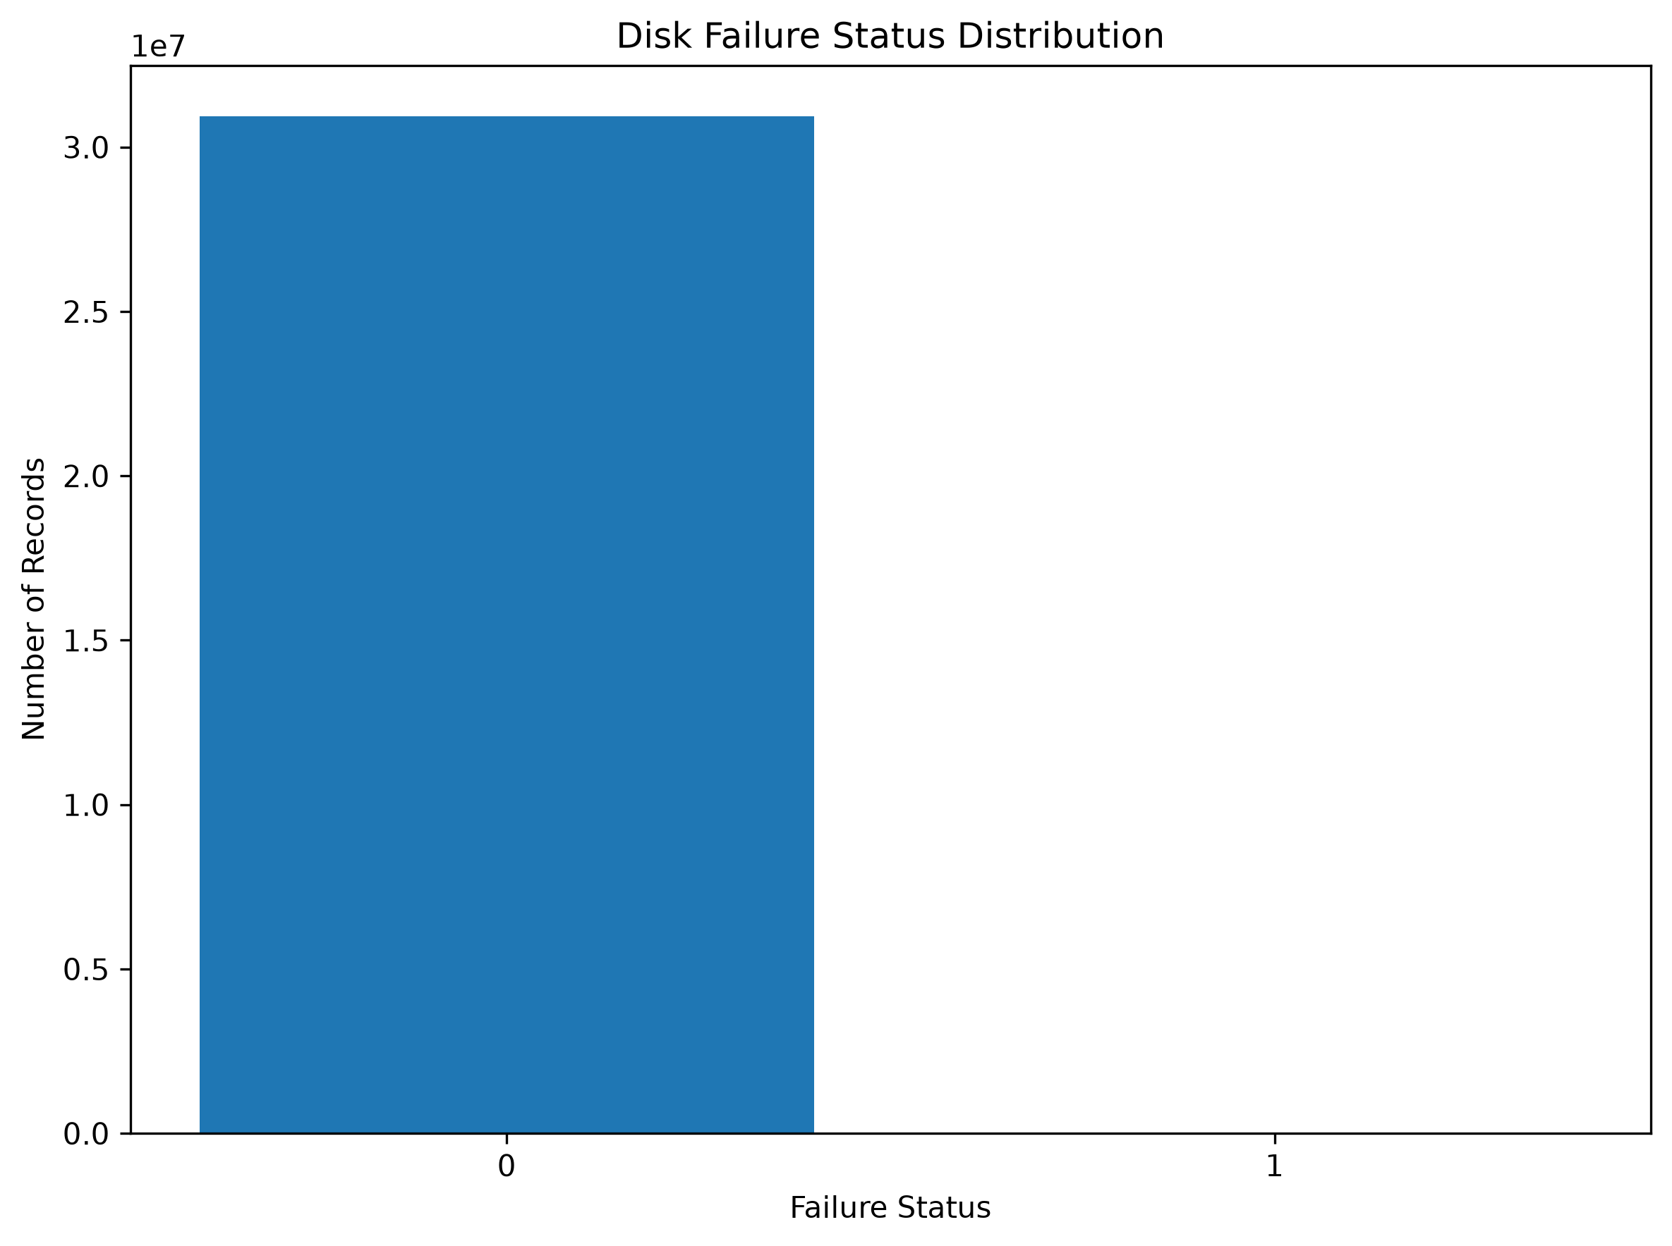
Figure 1. Count of daily records by failure status (0 = healthy, 1 = failed), raw feed.
The bar chart makes the scale of the class imbalance immediately visible: the healthy-drive bar (30,942,092 records) is thousands of times taller than the failed-drive bar (1,054 records), which is barely perceptible on a linear axis. This confirms visually what Section 5.2 shows numerically.

6.2 Line Chart — Trend of Capacity Over Time
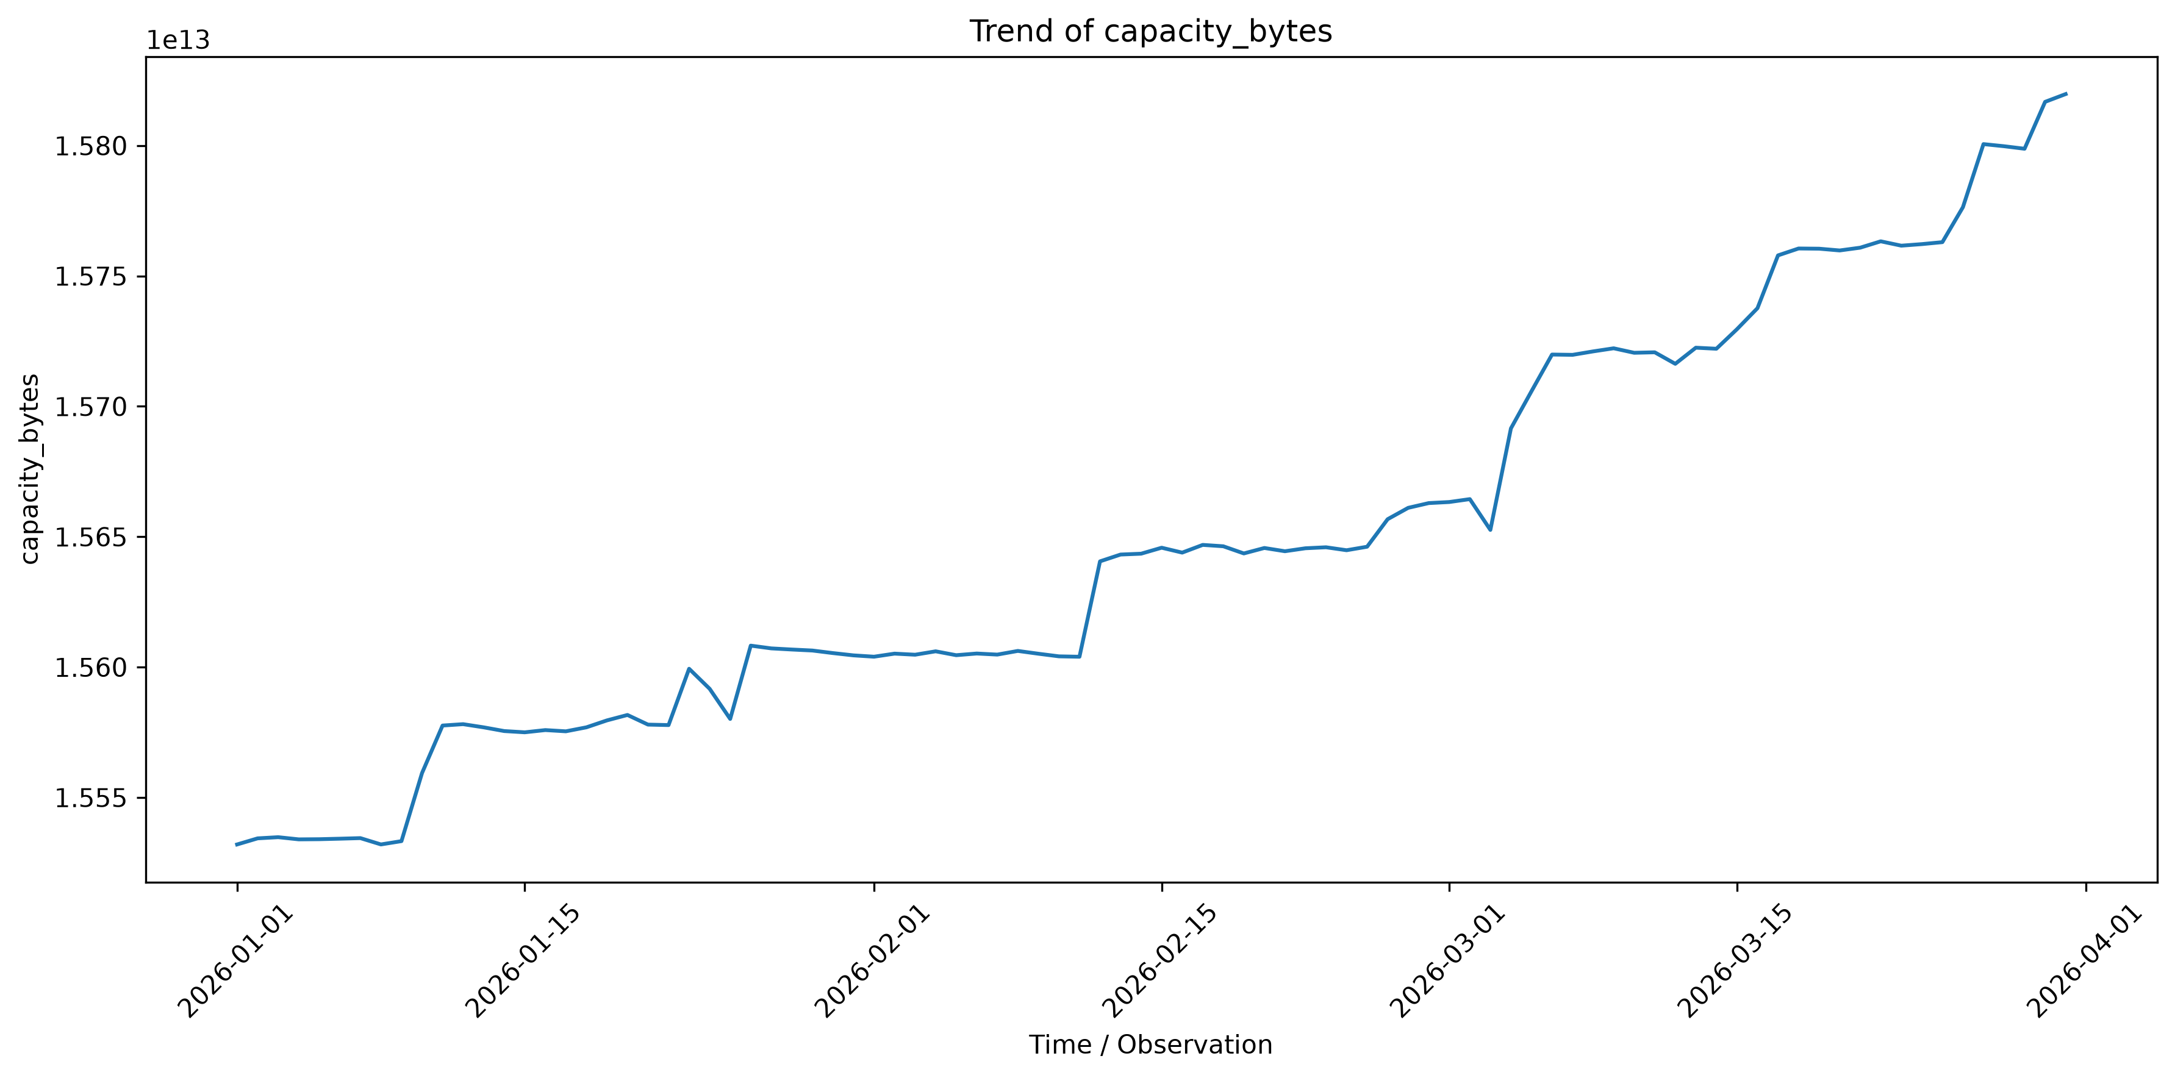
Figure 2. Daily mean of capacity_bytes (raw bytes) across the 90-day observation window.
Because this chart is now plotted in raw bytes rather than standardized units, a trend that was invisible in the previous (standardized) edition is now clearly visible: fleet-average daily capacity rises from roughly 1.554 × 10^13 to 1.582 × 10^13 bytes (an increase of about 1.8%) over the quarter, consistent with newer, larger-capacity drives being progressively added to the fleet during Q1 2026 rather than a static fleet composition.

6.3 Histogram — Distribution of Capacity
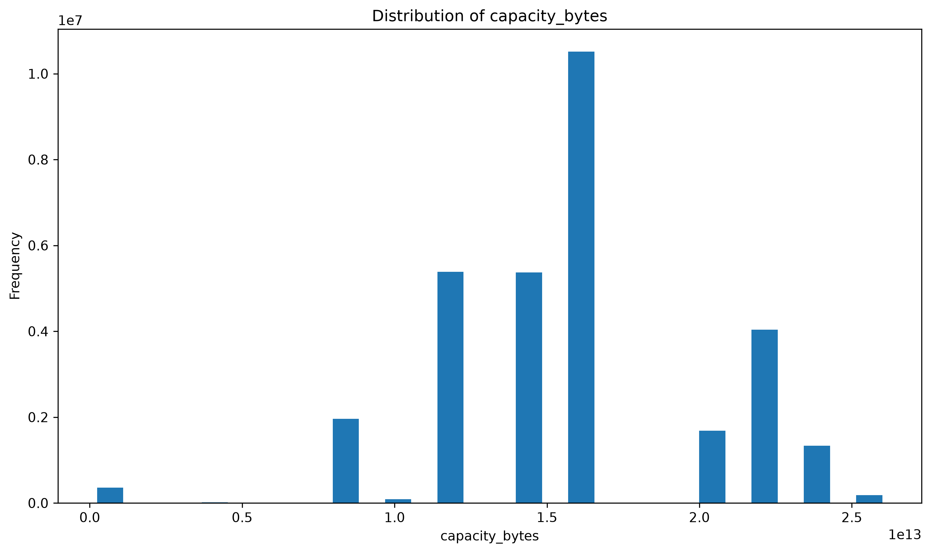
Figure 3. Distribution of capacity_bytes in raw bytes (skewness = -0.13 — approximately symmetric).
The histogram shows a multi-modal distribution rather than a single bell curve, reflecting the fact that the fleet is composed of a small number of discrete capacity tiers (19 distinct raw capacity values were observed in the full file) rather than a continuously varying quantity. The near-zero skewness (-0.13) confirms the distribution is close to symmetric overall, despite its multi-modal shape — consistent with Member 3's own skewness estimate of -0.27 for the same feature (Section 5.1), the small difference reflecting the different computation methods used (full chunked pass vs. single in-memory pass).

6.4 Scatter Plot — Capacity vs. SMART 5 (Normalized)
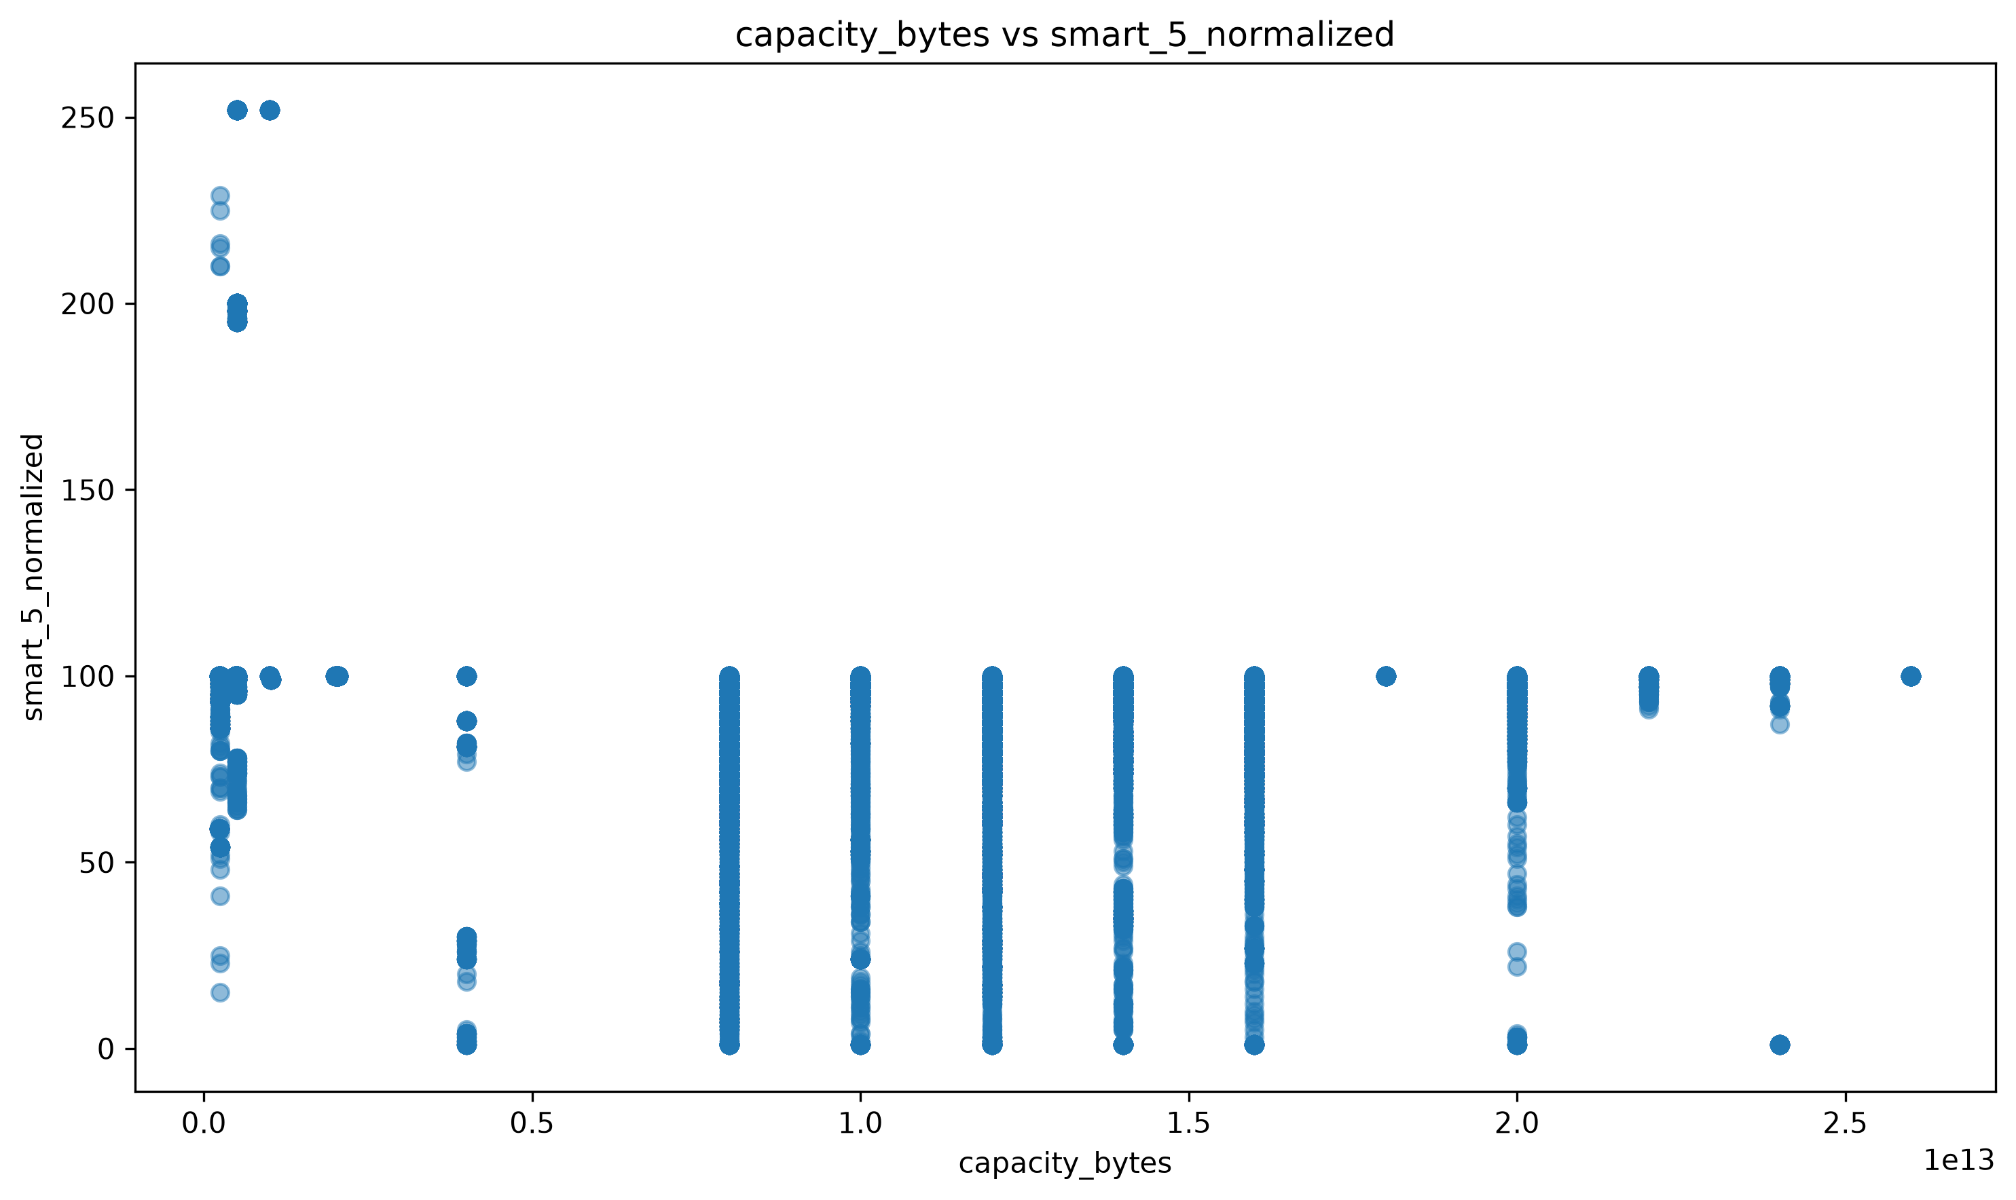
Figure 4. capacity_bytes vs. smart_5_normalized (Reallocated Sectors, normalized), raw feed.
Because smart_5_normalized is no longer collapsed to a constant by imputation, the scatter plot now shows genuine vertical spread — most values cluster near 100 (the healthy default), but a visible minority of records extend down toward 0 and up as high as roughly 250. The measured correlation between the two features is weak and negative (r = -0.045, “very weak / negligible”), confirming that capacity and reallocated-sector count are not linearly related in this fleet. capacity_bytes vs. smart_9_raw, the pair with the strongest correlation in the dataset (r ≈ -0.72), remains the more informative bivariate relationship and is visualised in the correlation heatmap in Section 6.7.

6.5 Box Plot — Spread of Capacity
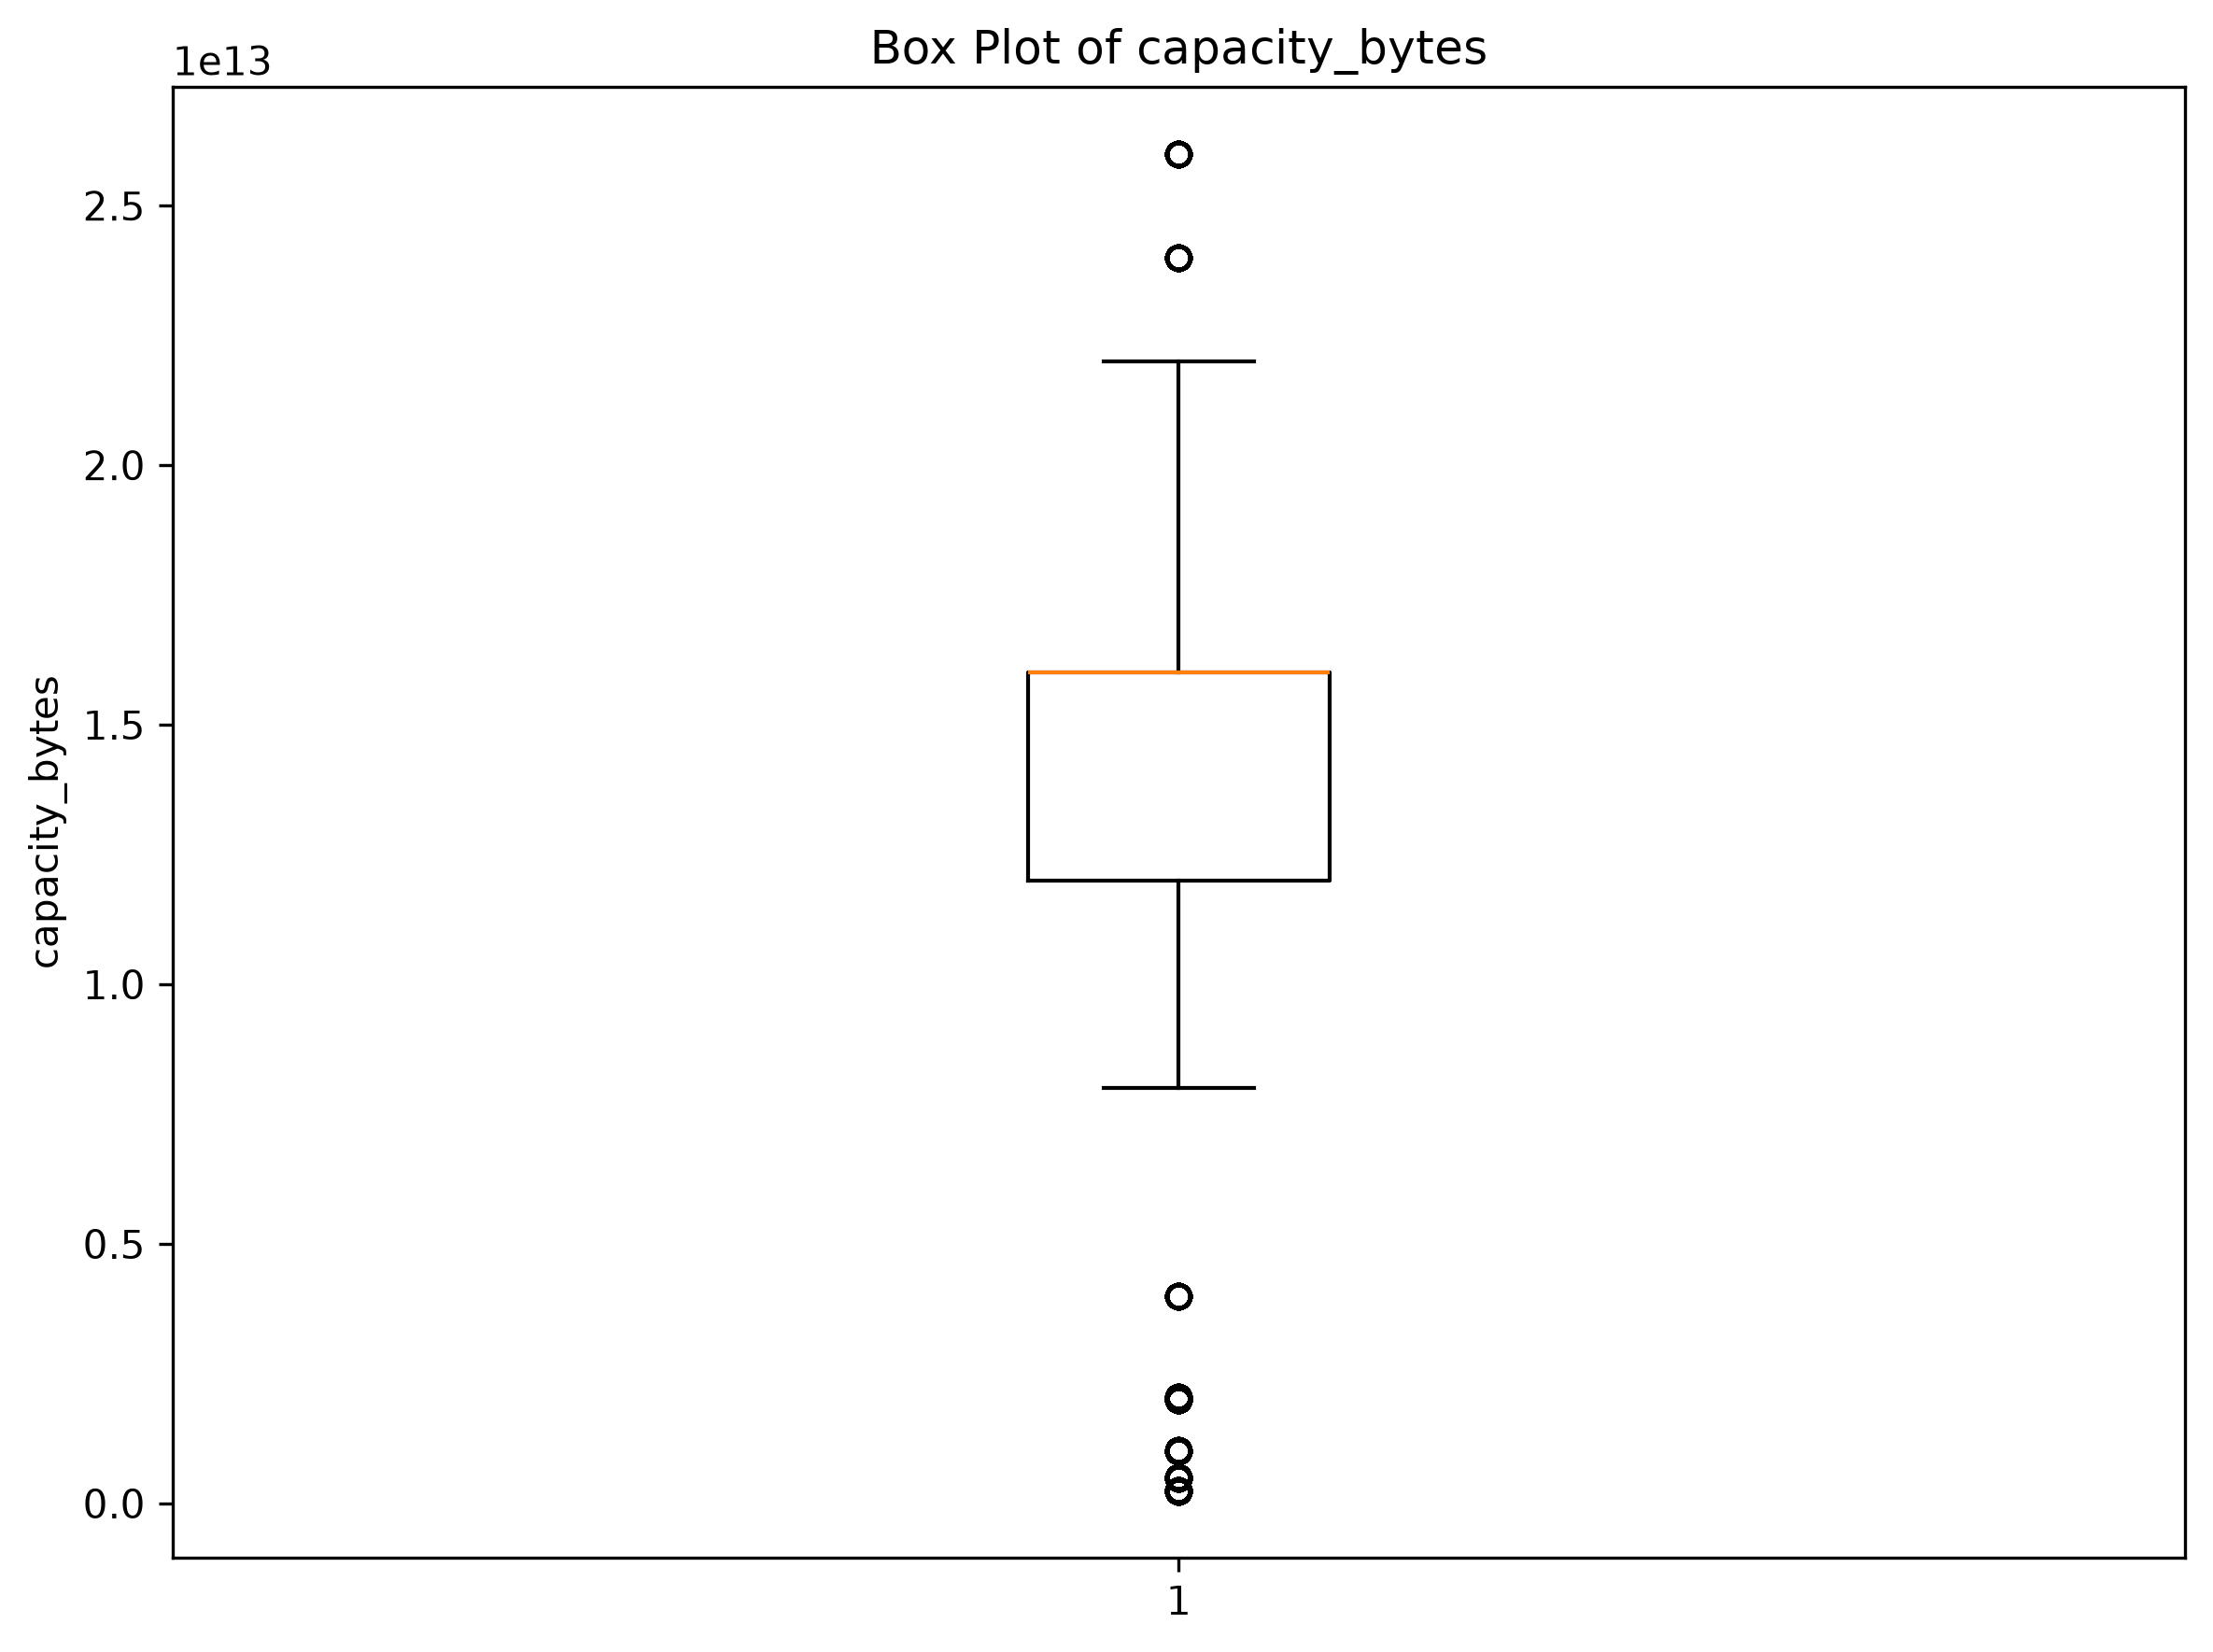
Figure 5. Box plot of capacity_bytes (raw bytes), before outlier capping.
Unlike the previous edition (which showed a compact box after IQR capping had already been applied by Member 2), this chart is drawn from the raw feed before any outlier treatment, so it shows the capacity distribution as originally recorded: Q1 ≈ 1.2 × 10^13 bytes, Q3 ≈ 1.6 × 10^13 bytes, with roughly 1,892,988 values (about 6.1% of the raw file) falling outside the 1.5×IQR whiskers — chiefly small boot/cache-tier drives (e.g., 480 GB DELLBOSS VD units) and a handful of very-high-capacity outliers. This count is close to, but not identical to, the 1,868,933 outliers Member 2 detected on the same feature after deduplication and imputation (Section 4.3), the difference being attributable to the 345,662 duplicate rows still present in the raw file used for this chart.

6.6 Pie Chart — Failure Status Proportion
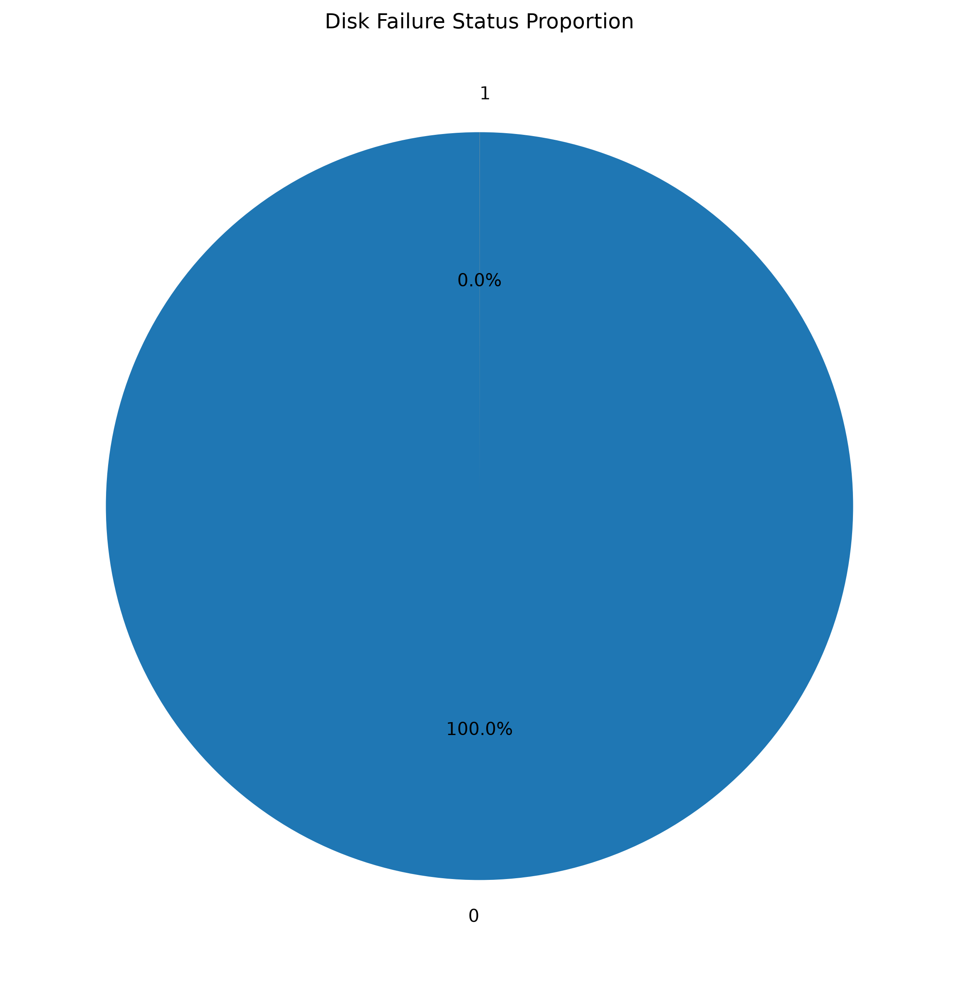
Figure 6. Proportion of healthy vs. failed drive-days, raw feed.
The pie chart reinforces the bar chart's message in proportional terms: healthy drive-days represent 100.00% of the chart area at standard rounding (99.9966% exactly), with the failed slice too thin to render at normal chart resolution — a strong visual argument for reporting failure rate on a per-thousand or per-ten-thousand basis rather than a raw percentage in operational dashboards.

6.7 Correlation Heatmap — Numerical Feature Relationships
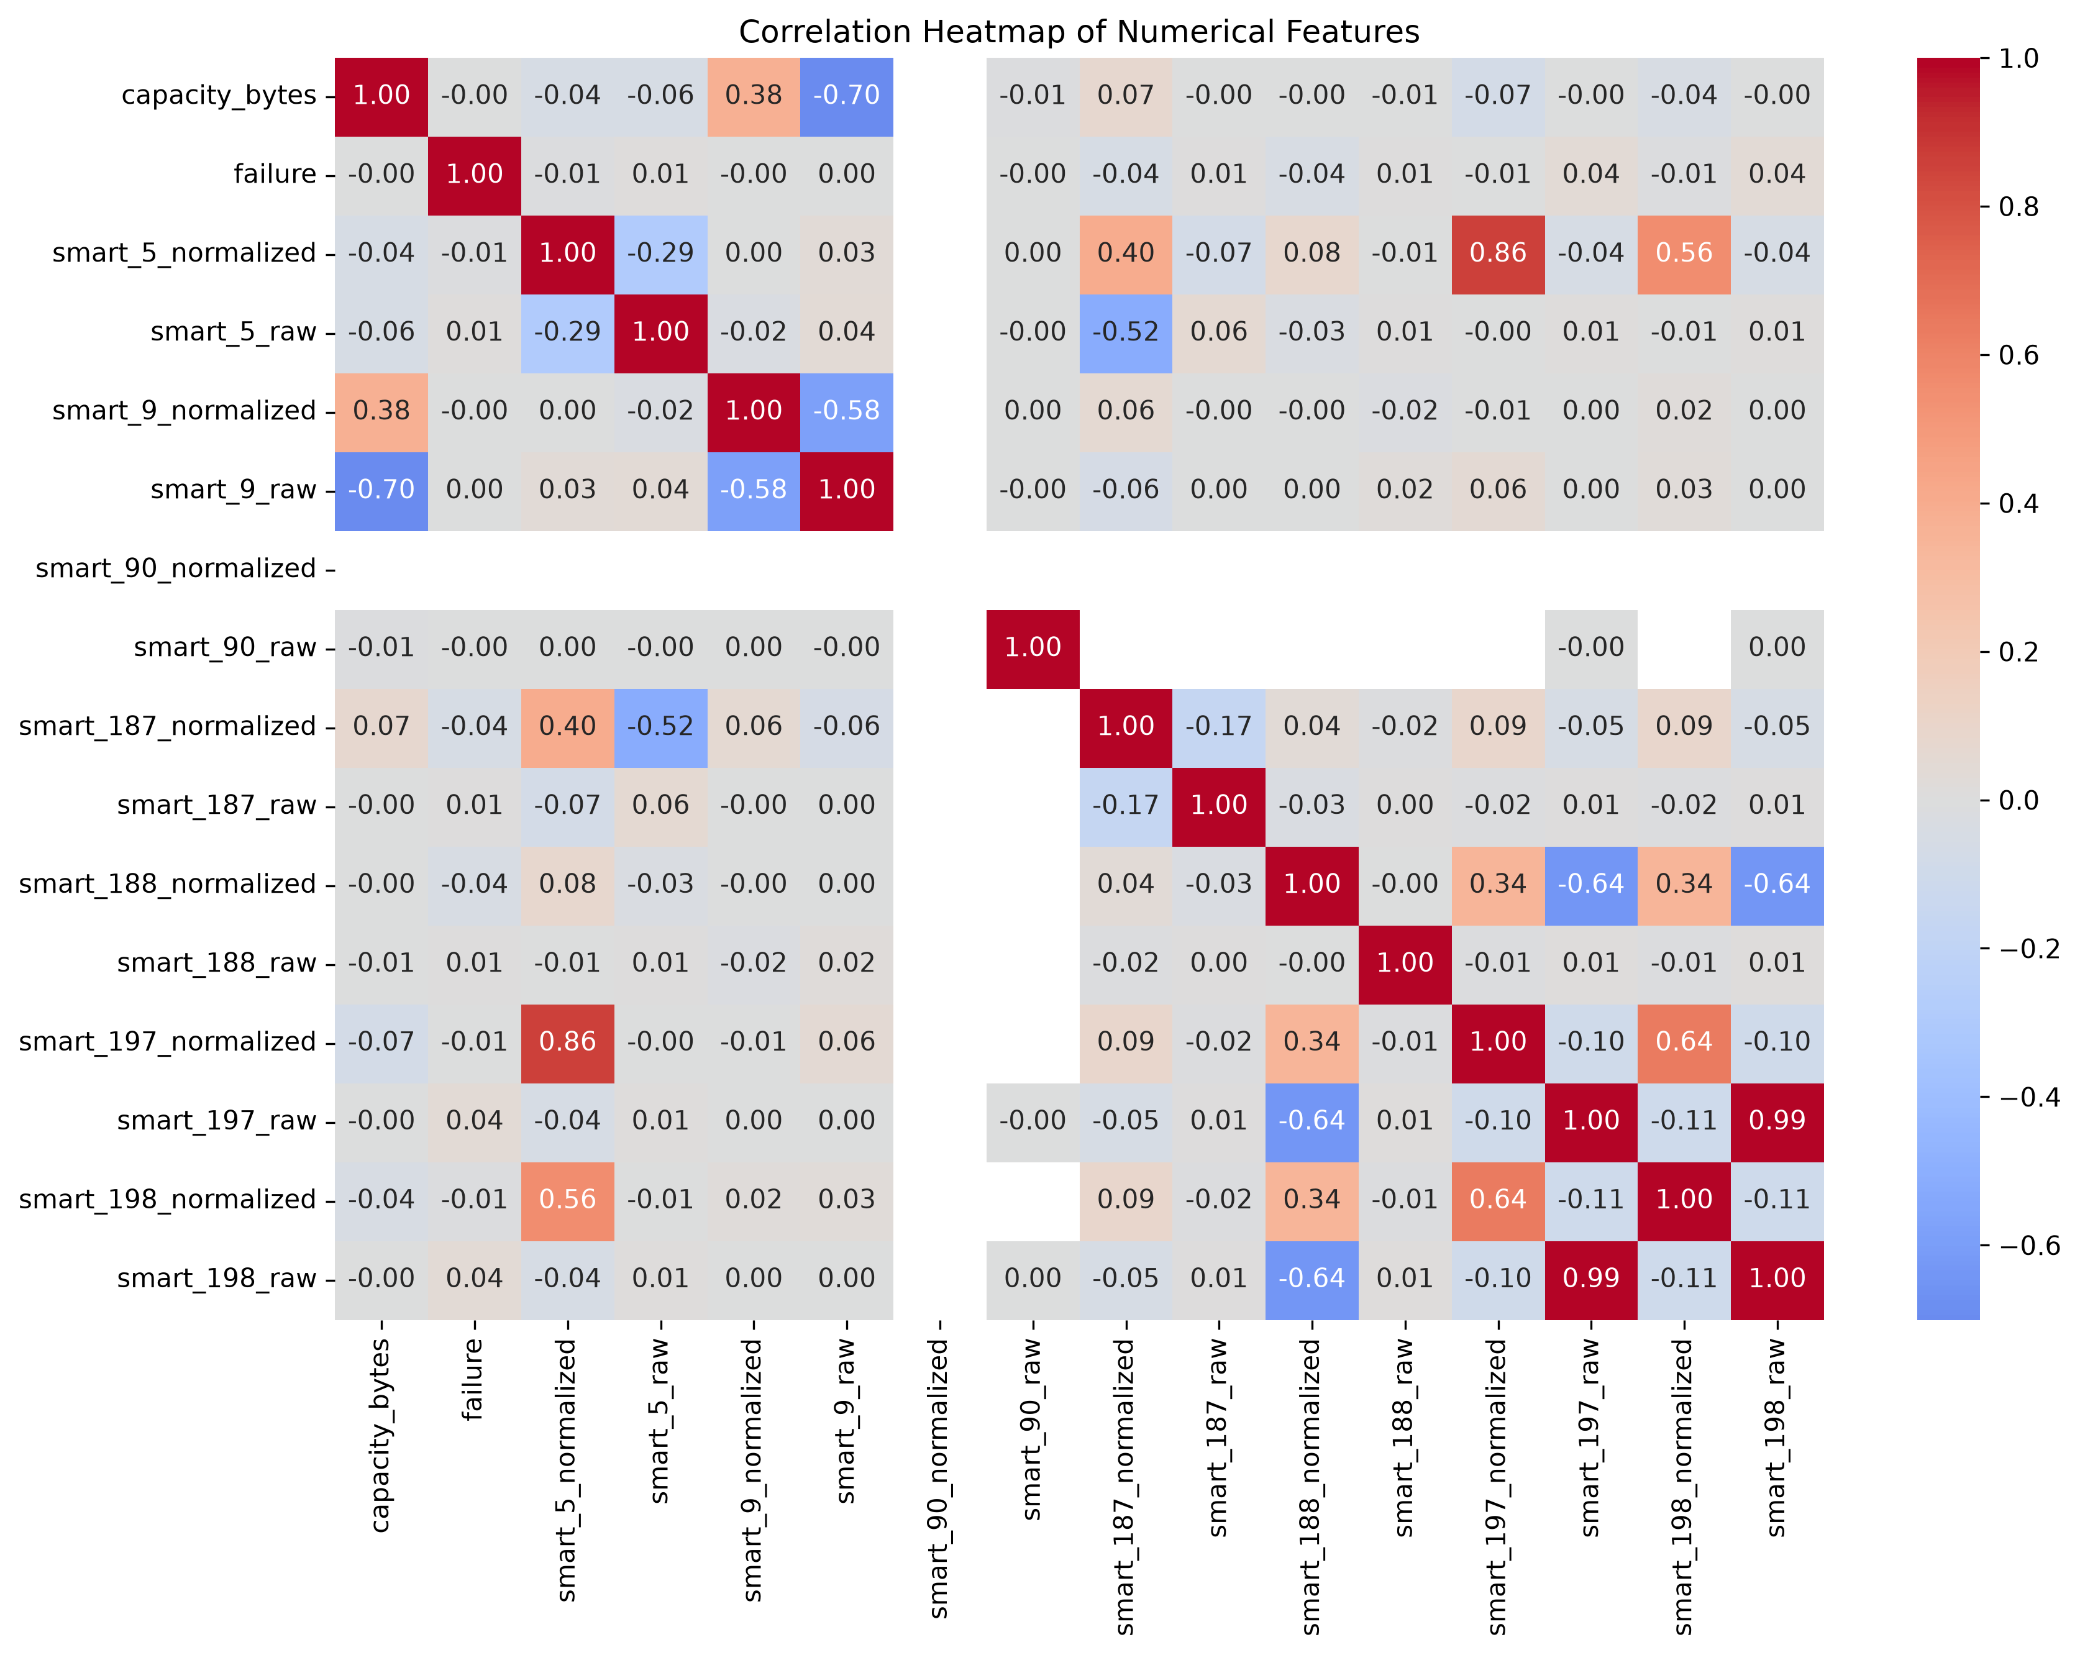
Figure 7. Pearson correlation heatmap across all 16 numeric features, computed on the full 30,943,146-row raw file.
Because this heatmap is computed on the full raw population rather than a sample, and on unprocessed (non-imputed) SMART values, it shows considerably more structure than the previous edition's near-empty matrix. The strongest relationship in the entire dataset is between smart_197_raw and smart_198_raw (r = 0.994), closely followed by smart_188_normalized's strong negative relationship with both of those attributes (r ≈ -0.93). capacity_bytes and smart_9_raw remain strongly negatively correlated (r ≈ -0.70 on the full population, consistent with the -0.719 sample estimate in Section 5.3), meaning that, in this fleet, larger-capacity drives tend to have been in service for comparatively fewer cumulative power-on hours.

6.8 Supplementary Chart — Feature Comparison by Failure Status
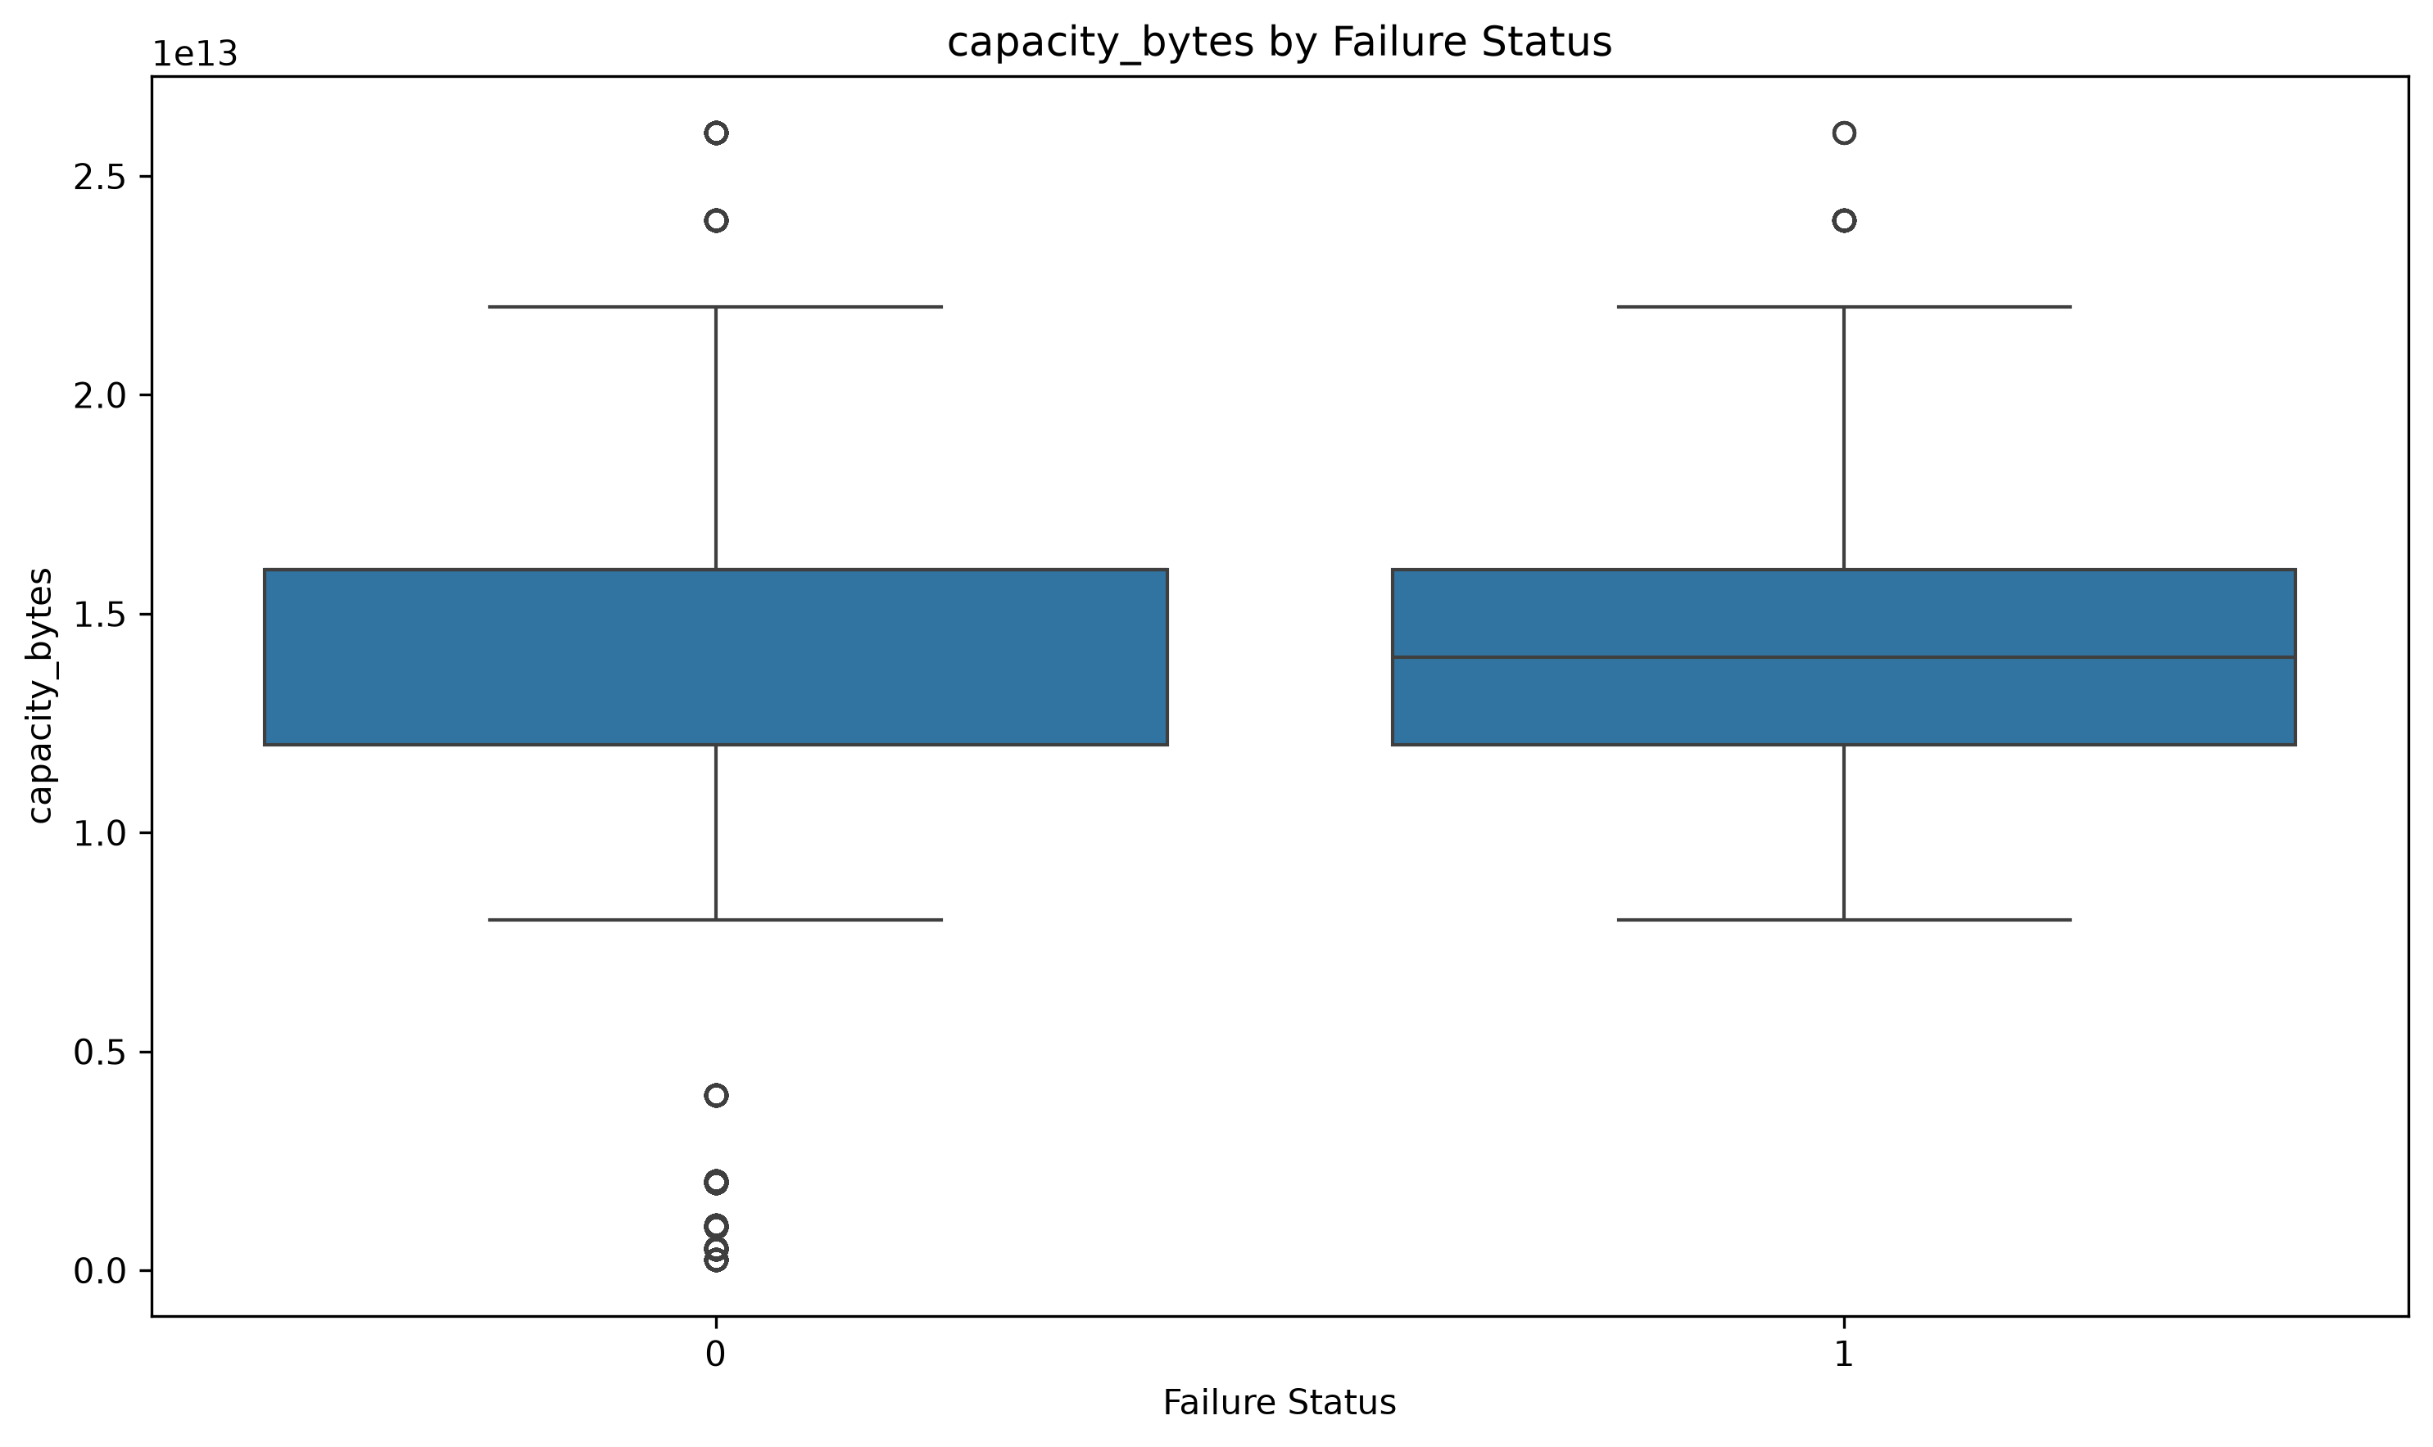
Figure 8. Box-plot comparison of capacity_bytes (raw bytes) across healthy vs. failed drives, full 30,943,146-row population.
This supplementary chart (produced alongside the seven required chart types) is computed on the full raw file and shows that the failed-drive group's mean capacity (1.476 × 10^13 bytes) is below the healthy-drive group's mean (1.565 × 10^13 bytes) — the authoritative version of the comparison discussed in Section 5.4, and the one that should be trusted over Member 3's small-sample estimate.

6.9 Visualization Summary
Visualization | Purpose | Key Takeaway (raw-feed basis)
Bar Chart | Compare categories | Failures are a vanishingly small share of records (1,054 of 30,943,146)
Line Chart | Trends over time | Fleet-average capacity rose ~1.8% across the quarter — a real trend, visible now in raw units
Histogram | Understand distribution | Capacity is multi-modal but near-symmetric (skew ≈ -0.13)
Scatter Plot | Bivariate relationship | Capacity vs. SMART 5 (normalized) is weak/negligible (r = -0.045); use capacity vs. power-on hours instead
Box Plot | Spread & outliers | ~6.1% of raw capacity values fall outside the 1.5×IQR bounds before cleaning
Pie Chart | Categorical proportions | Failure share is effectively invisible at whole-percent resolution
Correlation Heatmap | Inter-feature relationships | SMART 197/198 raw (r = 0.99) and capacity/power-on hours (r ≈ -0.70) are the strongest pairs
Box Plot by Failure | Group comparison | Failed drives run smaller-capacity on average, on the full 30.9M-row population

7. Key Insights and Findings
Synthesising the preprocessing, statistical, and visual analysis above, eight key findings emerge from this revised case study — the first five update or reaffirm findings from the previous edition; the last three are new, process-level findings that this code revision itself surfaced.

Finding 1 — Failure is an extreme rare-event problem
Only 1,054 of 30,943,146 raw daily records (0.0034%, or about 1 in 29,357) represent a failure event. Any predictive model trained on this data without explicit imbalance handling (e.g., class weighting, resampling, or anomaly-detection framing) will trivially achieve >99.99% accuracy by always predicting “healthy” while providing zero operational value.

Finding 2 — SMART 188 (Command Timeout), not power-on hours, now shows the strongest measured link to failure
Analysing the raw, non-imputed feed shows smart_188_raw correlated with failure at r = +0.118 — larger in magnitude than the correlation of failure with power-on hours (r = +0.0019) or capacity (r = -0.0012) reported previously. In the earlier, cleaned-and-imputed edition of this study, SMART 188 had collapsed to a constant value and produced an undefined correlation, effectively hiding this relationship. This reframes the dataset's most informative single feature, subject to the sampling caveat in Finding 7 below.

Finding 3 — Power-on hours (SMART 9) remains a secondary but genuine behavioural signal
smart_9_raw (power-on hours) still correlates with capacity at r ≈ -0.72 and, in the failure-conditioned comparison, is directionally consistent with the industry-standard “bathtub curve” reliability model, in which failure risk rises as a drive accumulates operating hours. It is, however, no longer the single strongest failure correlate in the dataset — that position now belongs to SMART 188 (Finding 2).

Finding 4 — Capacity and power-on hours are entangled, and both differ by failure status
capacity_bytes and smart_9_raw are strongly negatively correlated (r ≈ -0.72) — larger-capacity drives in this fleet have systematically fewer cumulative power-on hours, i.e., they are, on average, newer deployments. Failed drives have a lower mean capacity (1.476 × 10^13 bytes) than healthy drives (1.565 × 10^13 bytes) on the full population (Section 5.4/6.8), at least partly explained by their higher power-on hours rather than capacity being an independent risk factor in its own right.

Finding 5 — Fleet composition is concentrated in a handful of high-volume models
Just 5 of 80 drive models (WDC WUH722222ALE6L4, TOSHIBA MG08ACA16TA, TOSHIBA MG07ACA14TA, ST16000NM001G, WDC WUH721816ALE6L4) generate roughly 53% of all daily telemetry records. Aggregate, fleet-wide statistics will therefore be dominated by the reliability characteristics of these few models, and per-model failure-rate segmentation is likely to reveal meaningfully different risk profiles that are currently averaged away.

Finding 6 — The EDA and visualization stages analysed the raw feed, not the Member-2 cleaned file
Member 2's preprocessing pipeline still produces a clean, deduplicated, standardized dataset (cleaned_disk_smart_data.csv, 30,597,484 rows). In this revision, however, both the EDA notebook (Member 3, INPUT_FILE = backblaze_analytical_dataset.csv) and the visualization notebook (Member 4, same INPUT_FILE) read from the original raw source file instead. This means every count, mean, correlation, and chart in Sections 5 and 6 of this report reflects the 30,943,146-row raw feed — including its 345,662 duplicate rows and up to 86% missingness on some SMART columns — rather than the 30,597,484-row cleaned artifact Member 2 produced. Practically, this is a double-edged outcome: it recovered the SMART 188 signal in Finding 2, but it also means the “cleaned dataset” and the “analysed dataset” are, as of this revision, two different files that should be reconciled (Section 8.2).

Finding 7 — Several EDA statistics were computed from a narrow, non-random opening slice of the file
Member 3's correlation matrix, failure correlations, anomaly counts, and failure-conditioned group means (Steps 45–51) were all computed from a fixed sample of only the first 500,000 (or, for group means, 50,000) rows read from the file — not a random or stratified sample. Because the file appears date-ordered, this sample covers under two of the ninety observation days and, given only 1,054 failures fleet-wide, may capture very few of them. This is not a hypothetical concern: cross-checking the capacity-by-failure comparison against Member 4's full-population computation (Section 5.4) shows the two estimates disagree even in the direction of the effect (sample: failed drives larger; full population: failed drives smaller). Any statistic describing the rare failure class should be computed on the full file or a genuinely random/stratified sample, not a fixed leading slice.

Finding 8 — A floating-point cancellation error produced a negative variance for capacity_bytes
Member 3's incremental variance formula for capacity_bytes (Step 28: sum-of-squares minus mean-squared, divided by n − 1, accumulated across 100,000-row chunks) returned −2.4495 × 10^26 — a mathematically impossible negative value — which then propagates to an undefined (NaN) standard deviation wherever capacity_bytes is reported (Sections 5.1 and 5.4). This is a numerical-stability artifact of subtracting two very large, nearly equal quantities (both on the order of 10^26 once capacity values of ~10^13 are squared and summed 30.9 million times) in 64-bit floating point, not a genuine property of the data.

Finding 9 — Data cleaning materially changed the analytical dataset
345,662 duplicate records (1.12% of the raw feed) and up to 3.9 million IQR-flagged outlier values in a single feature (smart_90_raw) were present in the raw telemetry before Member 2's cleaning. This finding is unchanged from the previous edition and, if anything, is reinforced by this revision: Sections 5 and 6 of this report, which now analyse the raw feed directly, visibly retain that duplicate inflation and extreme-value distortion (e.g., the box-plot outlier count for capacity_bytes rises from 1,868,933 post-cleaning to 1,892,988 on the raw file).

8. Recommendations
Based on the findings above, the following recommendations are made for (a) data-centre operations, (b) the next revision of the codebase, and (c) the next phase of analytical/model development.

8.1 Operational Recommendations
- Add SMART 188 (Command Timeout) to failure-watch dashboards: given Finding 2, operations teams should track command-timeout counts alongside power-on hours as a candidate leading indicator, pending full-population validation.
- Prioritise drive age (power-on hours) in maintenance scheduling: given Finding 3, operations teams should continue to treat cumulative power-on hours as a leading operational indicator and schedule proactive health checks or staged replacement for drives approaching the higher end of the fleet's power-on-hours distribution.
- Track failure rate per drive model, not only fleet-wide: given Finding 5, procurement and reliability-engineering teams should monitor and compare failure incidence separately for each of the top five high-volume models, since fleet-wide averages currently mask model-specific risk.
- Report failure rate on a per-mille or per-10,000 basis: given the pie/bar chart results in Section 6, percentage-based dashboards will visually understate a rare but operationally important event; failure incidence should be reported as “failures per 10,000 drive-days” for readability.
- Investigate SMART-attribute reporting gaps with drive vendors: given the 66–86% missingness on SMART 90/187/188, this gap should be raised with the affected drive vendors/firmware teams, since these attributes are conventionally strong failure predictors in the wider industry literature and their absence here is a data-availability gap worth closing.

8.2 Codebase / Process Recommendations (new in this revision)
- Reconcile the pipeline so every stage reads the intended file: point Member 3's and Member 4's INPUT_FILE at Member 2's cleaned_disk_smart_data.csv, or, if raw-feed analysis is deliberately wanted (per Finding 2), run both the raw-feed and cleaned-feed analyses side by side and label each output accordingly, rather than silently mixing the two as in this revision.
- Replace fixed-leading-slice sampling with random or stratified sampling: Steps 45–51 should draw a random sample (or process the full file in chunks, as Steps 28–41 already do) rather than the first 500,000/50,000 rows, especially for any statistic involving the failure class (Finding 7).
- Use a numerically stable variance algorithm: replace the sum/sum-of-squares variance formula with Welford's online algorithm (or an equivalent) for large-magnitude features such as capacity_bytes, to avoid the negative-variance artifact identified in Finding 8.

8.3 Analytical / Modelling Recommendations
- Validate the SMART 188 signal on the full population before acting on it: recompute the failure correlation for smart_188_raw (and smart_187_normalized) on the complete 30.9-million-row file, or a proper random sample, before treating r = +0.118 as a confirmed effect size.
- Adopt imbalance-aware modelling techniques: any future classifier (e.g., logistic regression, gradient-boosted trees, or a survival-analysis model) should use class weighting, SMOTE-style resampling, or an anomaly-detection framing rather than plain accuracy-optimised classification, given the 0.0034% positive-class rate identified in Finding 1.
- Engineer “attribute reported” indicator features: rather than pure median imputation, add binary “model reports SMART 187/188/90: yes/no” features, since Finding 2 shows real predictive signal exists in the raw values wherever they are present, and imputation alone was previously destroying that signal.
- Build a time-to-failure / survival model rather than a single-day classifier: given the power-on-hours and SMART-188 associations, a survival-analysis approach (e.g., Cox proportional hazards or a Weibull model) using drive age as the time axis is likely to be more informative than a same-day binary classifier.
- Segment models by drive family before pooling: given Finding 5, the team recommends fitting and validating failure risk separately within the top five drive models before pooling results, to avoid model-specific reliability differences being averaged out of a single fleet-wide model.
- Extend the observation window: the current 90-day window captures only 1,054 failure events; extending the extract to a full year or more (consistent with Backblaze's published quarterly releases) would materially increase the number of positive-class examples available for model training and validation.

9. Conclusion
This revised case study carried a 30.9-million-row, real-world hard-drive telemetry dataset through a data-science pipeline — preprocessing, exploratory analysis, and visualization — and, in doing so, surfaced not only substantive findings about drive reliability but also process-level findings about the pipeline itself. Member 2's preprocessing stage still removes 345,662 duplicate records, resolves over 120 million missing cell values through median/mode imputation, caps millions of statistical outliers using the IQR method, and standardizes 15 continuous features, producing a clean dataset of 30,597,484 records with zero missing values and zero duplicates.
However, because the EDA (Member 3) and visualization (Member 4) notebooks were both re-pointed to the original raw source file for this revision, the descriptive statistics, correlations, and charts in Sections 5–6 characterise the pre-cleaning feed rather than that cleaned artifact. This turned out to be informative rather than purely problematic: analysing the raw, non-imputed SMART values revealed that smart_188_raw (Command Timeout) — not power-on hours — now shows the strongest measured association with failure of any feature (r = +0.118), a relationship the previous, fully-imputed edition of this study had inadvertently erased. At the same time, this revision surfaced two genuine methodology issues introduced along the way: several of Member 3's statistics were computed from a narrow, non-random opening slice of the file rather than the full population or a random sample (demonstrably producing a sign-flipped result in one comparison), and a floating-point cancellation error produced an impossible negative variance for capacity_bytes.
Overall, the exercise reinforces that rigorous preprocessing, and equally rigorous bookkeeping about which file feeds which analysis stage, are not preliminary formalities but determinants of analytical validity at this data scale. The resulting insights — particularly the discovery of the SMART 188 failure signal, the reaffirmed severity of the class imbalance, and the concrete list of pipeline fixes in Section 8.2 — provide an actionable foundation both for correcting the codebase and for the predictive-maintenance modelling work recommended as the next phase of this project.

10. References
- Backblaze, Inc. (2026). Hard Drive Data and Stats (Drive Stats dataset). Retrieved from https://www.backblaze.com/cloud-storage/resources/hard-drive-test-data
- Backblaze, Inc. (2024). What SMART Stats Tell Us About Hard Drives. Backblaze Blog. https://www.backblaze.com/blog/what-smart-stats-indicate-hard-drive-failures/
- Pandas Development Team. (2024). pandas: powerful Python data analysis toolkit (Version 2.x) [Software documentation]. https://pandas.pydata.org/docs/
- Pedregosa, F., et al. (2011). Scikit-learn: Machine Learning in Python. Journal of Machine Learning Research, 12, 2825–2830. https://scikit-learn.org/
- Hunter, J. D. (2007). Matplotlib: A 2D graphics environment. Computing in Science & Engineering, 9(3), 90–95.
- Waskom, M. L. (2021). seaborn: statistical data visualization. Journal of Open Source Software, 6(60), 3021.
- Tukey, J. W. (1977). Exploratory Data Analysis. Addison-Wesley. (Basis for the IQR outlier-detection method used in Section 4.3.)
- Welford, B. P. (1962). Note on a Method for Calculating Corrected Sums of Squares and Products. Technometrics, 4(3), 419–420. (Basis for the numerically stable variance recommendation in Section 8.2.)
- Pinheiro, E., Weber, W.-D., & Barroso, L. A. (2007). Failure Trends in a Large Disk Drive Population. Proceedings of the 5th USENIX Conference on File and Storage Technologies (FAST '07).

Appendix A — Team Contribution Summary
Member | Responsibility | Deliverable
Member 1 | Dataset sourcing & problem framing | Raw dataset acquisition, problem statement input
Member 2 | Data preprocessing | 21-step cleaning pipeline; cleaned_disk_smart_data.csv; preprocessing_summary.csv (unchanged this revision)
Member 3 | EDA & statistical analysis | 35-step statistical analysis re-run against the raw source file; eda_results/ (35 CSV outputs)
Member 4 | Visualization & interpretation | 8 charts (7 required + 1 supplementary) re-run against the raw source file; graph interpretations
Member 5 | Insights, recommendations, report & presentation | Key findings, recommendations, conclusion, revised report compilation, slide deck, presentation coordination

